**Project 21 - CCNP Route For A Global Health Network**

Project Plan

Version 10.0

Date

1/11/2025

# Copyright

# Declaration

I hereby declare that this submission is my own work and that, to the best of my knowledge and belief, it contains no material previously published or written by another person nor material which to a substantial extent has been accepted for the award of any other degree or diploma of the university or other institute of higher learning, except where due acknowledgment has been made in the text.

I acknowledge that used Artificial intelligence (A.I) tools such as ChatGPT were used only for brainstorming and organizing ideas and content and using QuillBot for summarizing, grammar checking.

**Signature:** Husain Ali **Name:** Husain Ali **Date:** 20/10/2025

# Document control

This section includes the approvals on the document, change control, distribution list and change summary

## Document Change Control

|  |  |
| --- | --- |
| Initial Release: | 14/9/2025 |
| Current Release: | 1/11/2025 |
| Date of Last Review: | 1/11/2025 |
| Date of Next Review | - |
| Target Date for Next Update: | - |

Table 1 Document Change Control

## Distribution List

This following list of people shall receive a copy of this document every time a new version of this document becomes available:

|  |  |
| --- | --- |
| Husain Ali | Project Manager |
| Bahrain Polytechnic | Sponsor |
| Jon Nolen | Client |
| Dr. Ayman Alani | Expert |
| Dr. Ayman Alani | Supervisor |
| Husain Ali | Network Designer |
| Husain Ali | Network Engineer |
| Husain Ali | Security Specialist |
| Husain Ali | Tester |
| Husain Ali | System Administrator |
| Husain Ali | Project Analyst |
| Husain Ali | Risk Officer |
| Husain Ali | Quality officer |

Table 2 Distribution List

## Change Summary

The following table details changes made between versions of this document

|  |  |  |  |
| --- | --- | --- | --- |
| Version | Date | Modifier | Description |
| 1.0 | 24/9/2025 | Husain Ali | Added Scope Management |
| 2.0 | 7/10/2025 | Husain Ali | Added Human Resource Management |
| 3.0 | 9/10/2025 | Husain Ali | Added Time Management |
| 4.0 | 13/10/2025 | Husain Ali | Added Cost Management |
| 5.0 | 15/9/2025 | Husain Ali | Added Communication Management |
| 6.0 | 16/10/2025 | Husain Ali | Added Procurement Management |
| 7.0 | 19/10/2025 | Husain Ali | Added Quality Management |
| 8.0 | 20/10/2025 | Husain Ali | Added Risk Management |
| 9.0 | 23/10/2025 | Husain Ali | Finalise Appendix |
| 10.0 | 1/11/2025 | Husain Ali | Finalise the Project Plan Document |

Table 3 Change Summary

**Table of Contents**

Copyright 2

Declaration 3

Document control 4

Document Change Control 4

Distribution List 4

Change Summary 4

**Table of Tables:** 10

**Table of Figures:** 11

**Scope Management** 14

Introduction: 14

RACI 14

Approach: 14

Scope Definition: 15

Scope Statement: 15

Work Breakdown Structure: 17

Scope Verification: 21

Scope Control: 21

**Human Resource Management Plan** 22

Introduction: 22

Human Resource Management Process: 22

RACI 23

Human Management Approach: 23

Responsibility Assignment Matrix (RAM): 23

Visual Report: 23

Reports: 24

Responsibility Assignment Matrix: 24

Resource Work Summary Report: 26

Resource Work availability Report: 27

**Time Management:** 28

Introduction: 28

Process: 28

RACI 29

Schedule Management Approach: 29

Changes: 30

Reports: 31

Gantt chart: 31

Network diagram: 34

Baseline Report: 46

Critical Task Status Report: 47

Schedule Performance Index and Schedule Variance report: 48

**Cost Management:** 52

Introduction: 52

Process: 52

RACI 53

Cost Management Approach: 53

Changes: 53

Report: 55

Resource sheet - Entry View: 55

Resource Sheet – Cost View 56

Cost Variance and Cost Performance Index 57

Budget Cost Report: 60

Baseline Cost Report: 61

Cost-Benefit Analysis Report: 62

Payback Period 62

**Communication Management:** 64

Introduction 64

Processes: 64

RACI 65

Communication Approach: 65

Reports: 67

Stakeholder Communication Analysis: 67

Expectations Management Matrix 68

Stakeholders Management Strategy and Influence Matrix 68

**Procurement Management:** 69

Introduction 69

Processes 69

RACI 70

Procurement approach 70

**Quality Management:** 71

Introduction: 71

Processes: 71

RACI 72

Quality Management Approach: 72

Approach: 72

Test case: 73

Report 74

Quality Requirement Matrix 74

**Risk Management:** 76

Introduction: 76

Process: 76

RACI 77

Risk Management Approach: 77

Approach: 77

Risk Register: 78

Report 78

**Integration Management Plan and Closing Plan:** 80

Introduction: 80

Approach: 80

RACI 81

Reports: 81

**Legal, Ethical, Social and Professional Issues (LESPI)** 82

Potential Legal Issues 82

Potential Ethical Issues 82

Potential Social Issues 82

Potential Professional Issues 82

**Approval Signatures** 83

**Appendices** 84

**Appendix 1: Problem Analysis** 84

Ishikawa diagram: 84

**Appendix 2: Requirements Gathering & Analysis** 85

Interview Plan 85

Research Plan 87

Functional Requirements 90

Behaviour / Non-Functional Requirements 92

Design Requirements 93

Appendix 3: Decision Analysis 94

COTS Matrix Overview 94

COTS Weighted Score 96

Decision Statement 97

A Feasibility Analysis: 98

**References** 102

# **Table of Tables:**

Table 1 Document Change Control 4

Table 2 Distribution List 4

Table 3 Change Summary 5

Table 4 RACI- Scope Management Plan 14

Table 5 In-scoop Out-scoop 14

Table 6 RACI - Human Resources Management Plan 23

Table 7 Human Resources Management -Responsibility Assignment Matrix 25

Table 8 RACI – Time Management Plan 29

Table 9 RACI - Cost Management Plan 53

Table 10 Stakeholder Communication Analysis 67

Table 11 Expectations Management Matrix 68

Table 12 Stakeholders Management Strategy and Influence Matrix 68

Table 13 RACI - Procurement Management Plan 70

Table 14 RACI - Quality Management Plan 72

Table 15 Quality - Test Case 74

Table 16 Quality Requirement Matrix 75

Table 17 RACI - Risk Management 77

Table 18 Risk Register Report 79

Table 19 RACI - Integration Management Plan and Closing Plan 81

Table 20 Integration Management Report 81

Table 21 Approval Signatures 83

Table 22 Appendix 2 - Interview Plan 86

Table 23 Appendix 2 - Research Plan 88

Table 24 Appendix 2 - Functional Requirements 91

Table 25 Appendix 2 - Non-Functional Requirements 92

Table 26 Appendix 2 - Design Requirements 93

Table 27 Appendix 3 - COTS Matrix Overview 95

Table 28 Appendix 3 - COTS Weighted Score 97

# **Table of Figures:**

Figure 1 WBS – Overview Project Distribution 17

Figure 2 WBS - Initiation phase 17

Figure 3 WBS - Planning phase overview 17

Figure 4 WBS - Scope Management Plan 18

Figure 5 WBS - Human Resources Management Plan 18

Figure 6 WBS - Time Management Plan 18

Figure 7 WBS - Cost Management Plan 18

Figure 8 WBS - Communication Management Plan 18

Figure 9 WBS - Procurement Management Plan 19

Figure 10 WBS - Quality Management Plan 19

Figure 11 WBS - Risk Management Plan 19

Figure 12 WBS - Execution overview Phases 19

Figure 13 WBS - Network Design & Planning phase 19

Figure 14 WBS - Network Implementation Phase 19

Figure 15 WBS - Security Implementation Phase 20

Figure 16 WBS - Server & Service Implementation Phase 20

Figure 17 WBS - End User Setup Phase 20

Figure 18 WBS - Testing & Validation Phase 20

Figure 19 WBS - Monitoring and Controlling Overview Phase 20

Figure 20 WBS - Project Closure Overview Phase 20

Figure 21 Human Resources Management - Resource Work Summary Report 26

Figure 22 Human Resources Management - Resource Work availability Report 27

Figure 23 Gantt Chart - Initiation phase 31

Figure 24 Gantt Chart - Planning phase Part 1 31

Figure 25 Gantt Chart - Planning Phase Part 2 32

Figure 26 Gantt Chart - Excitation Phase Part 1 32

Figure 27 Gantt Chart - Project closure Phase 33

Figure 28 Gantt Chart - Execution Phase Part 2 33

Figure 29 Gantt Chart - Monitoring and Controlling Phase 33

Figure 30 Network Diagram Overview Part 1 34

Figure 31 Network Diagram Overview Part 2 34

Figure 32 Network Diagram - Intiaiton Phase Part 1 35

Figure 33 Network Diagram - Initiation Phase Part 2 35

Figure 34 Network Diagram - Planning Scope Management Phase Part 1 35

Figure 35 Network Diagram - Planning Scope Management Phase Part 2 36

Figure 36 Network Diagram - Planning Scop Management Phase Part 3 36

Figure 37 Network Diagram - Planning Scop Management Phase Part 4 37

Figure 38 Network Diagram - Planning Scop Management Phase Part 5 38

Figure 39 Network Diagram - Planning Human Resource Management Phase 38

Figure 40 Network Diagram - Planning Time Management Phase Part 1 39

Figure 41 Network Diagram - Planning Time Management Phase Part 2 39

Figure 42 Network Diagram - Planning Cost Management part 1 39

Figure 43 Network Diagram - Planning Cost Management Phase Part 2 39

Figure 44 Network Diagram - Planning Communication Management Phase 40

Figure 45 Network Diagram - Planning Procurement Phase 40

Figure 46 Network Diagram - Planning Quality Phase Part 1 40

Figure 47 Network Diagram - Planning Quality Phase Part 2 40

Figure 48 Network Diagram - Planning Risk Management Phase 41

Figure 49 Network Diagram - Execution Network Design & Planning Part Phase 1 41

Figure 50 Network Diagram - Execution Network Design & Planning Phase Part 2 41

Figure 51 Network Diagram - Network Implementation Execution Phase 42

Figure 52 Network Diagram – Execution Security Phase 42

Figure 53 Network Diagram - Execution Phase - Server & Services 42

Figure 54 Network Diagram - Excitation End User Setup Phase 42

Figure 55 Network Diagram - Execution Test & Validations Phase 43

Figure 56 Network Diagram - Monitoring & Planning Phase Part 1 43

Figure 57 Network Diagram - Monitoring & Planning Phase Part 2 43

Figure 58 Network Diagram - Project Closure Phase Part 1 44

Figure 59 Network Diagram - Project Closure Phase Part 2 44

Figure 60 Network Diagram - Project Closure Phase Part 3 45

Figure 61 Baseline Report 46

Figure 62 Critical Task Status Report 47

Figure 63 Baseline Schedule - Initiation Phase 48

Figure 64 Baseline Schedule - Planning Phase Part 1 49

Figure 65 Baseline Schedule - Planning Phase Part 2 50

Figure 66 Baseline Schedule - Execution Phase 50

Figure 67 Baseline Schedule - Monitoring & Controlling Phase 51

Figure 68 Baseline Schedule - Project Closure Phase 51

Figure 69 Resource sheet - Entry View 55

Figure 70 Resource Sheet – Cost View 56

Figure 71 Baseline Cost - Initiation Phase 57

Figure 72 Baseline Cost - Planning Phase Part 1 57

Figure 73 Baseline Cost - Planning Phase Part 2 58

Figure 74 Baseline Cost - Execution Phase Part 1 58

Figure 75 Baseline Cost - Execution Phase part 2 59

Figure 76 Baseline Cost - Monitoring and controlling Phase 59

Figure 77 Baseline Cost - Project Clouser Phase 59

Figure 78 Budget Cost Report 60

Figure 79 Baseline Cost Report 61

Figure 80 Cost-Benefit Analysis 62

Figure 81 Cost-Benefit Analysis - Payback Period 62

Figure 82 Cost-Benefit Analysis - Payback Period Graph 63

Figure 83 RACI - Communication Management Plan 65

Figure 84 Appendix 1 - Ishikawa diagram 84

Figure 85 Appendix 2 - A high-level topology 89

Figure 86 Appendix 3 - Resource sheet - Entry View 98

Figure 87 Appendix 3 - Resource Sheet - Cost View 99

Figure 88 Appendix 3 - Cost-Benefit Analysis 100

Figure 89 Appendix 3 - Payback Period 100

Figure 90 Appendix 3 - Payback Period graph 101

# **Scope Management**

## Introduction:

The scope management plan is a process that guarantees that a project product is precisely what is needed, nothing more and nothing less. It provides clear techniques and instructions for the gathering requirements, settings limits, and managing modifications for the agreed scope. It performs as a map for the project team, to support them in staying focus on the predetermined objectives and avoiding scope creep and pointless work. By following this structured the project manager can stay focused on critical deliverables that forward the project's goal by adhering to the plan.

### RACI

|  |  |  |  |
| --- | --- | --- | --- |
| Responsible | Accountable | Consulted | Informed |
| Project Manager | Project Manager | Client, Supervisor | Sponsor, Client |

Table 4 RACI- Scope Management Plan

### Approach:

For this project will take the scoop-in and scoop-out aspect.

The technique will establish the project's goals and parameters while keeping tasks in order. The project's in-scope and out-of-scope are shown in the following table.

|  |  |
| --- | --- |
| In-scoop | Out-scoop |
| Fully functional network | Assigned AS number |
| Implementing FTP, DNS, Webserver, DHCP and E-mail | Assigned Public IP |
| Implementing AAA server | Assigned Network bandwidth |
| Implementing DMVPN |
| Implementing routing protocols EIGRP, OSPF, BGP and router reflector |
| Segmenting the network into Vlans |
| The network must have methods to Connect remotely |
| Configure network devices and windows machine and PCs |

Table 5 In-scoop Out-scoop

## Scope Definition:

Defining the scope definition is completed by using multiple methods. The first method that helped to identify scope management are using the Ishikawa diagram since it make brainstorming and thinking of the main causes easier and more efficient. The second method is conducting an interview with the clients to identify their needs and requirements. Furthermore, the project charter document was very helpful since it talks about the client’s current system, background, policies and procedures which will be a great addition to make the process of identifying the scope much easier in addition to the project purpose and description

## Scope Statement:

* **Product Scope Description:**

The scope statement is to develop, build up, and validate an advance WAN routing system that offers enterprise-scale operations excellent performance, security, and dependability is the project's scope. The result will present documented and full functional network that can deal with real-world situations.

* **Product Acceptance Criteria:**

For the network to be acceptance by the client it must have:

1. The network infrastructure and configured are completed and delivered by or before the deadline ends.
2. The security measures comply with international security standers such as ISO 27001.
3. The GHN fully functional and can be access across all users and sites.
4. The full project complies with the allocated budget.
5. The last setup has to achieve the main projects objectives which are secure, reliable and efficient.

* **Project Deliverables:**

The new network for Global health network that contains the following:

* Fully functional Network Infrastructure.
* Server Implementations (FTP, DNS, Web, E-mail, DHCP).
* Routing Protocol Deployment.
* BGP with Route Reflector.
* DMVPN Configuration.
* VLAN Segmentation.
* Remote Access Solutions.
* Network devices and Windows machines Configuration.
* **Project Exclusions:**

the thing that out-scoop of the project that contains the following:

* Assigning AS number.
* Assigning public IP.
* Assigning network bandwidth.
* **Project Constraints:**

The limitation in the project:

* Project duration and allocated budget is fixed.
* The speed of the network will be fixed by the ISP.
* Physical space and cabling infrastructure.
* Network downtime.
* **Project Assumptions:**
* All network devices and servers will have compatible hardware and software versions.
* The organization will provide required licenses for routers, switches, and security tools.
* All testing and simulations will be performed in a controlled environment before deployment.
* Adequate power supply and physical infrastructure.

## Work Breakdown Structure:

The below figure represents the Work breakdown structure (WBS) that is a visual representation for all the workload required to complete the project. The workload is divided to tasks and subtasks all for the project manager to effectively manage the project scope as all team member work.

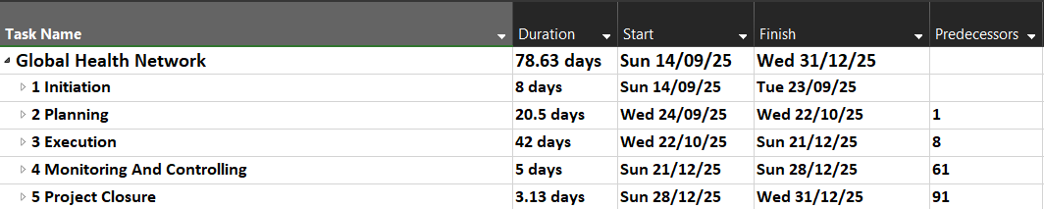

Figure 1 WBS – Overview Project Distribution

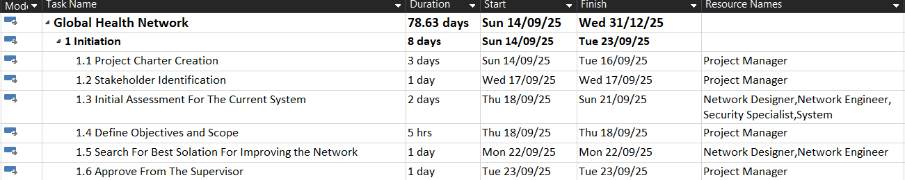

Figure 2 WBS - Initiation phase

Figure 3 WBS - Planning phase overview

Figure 4 WBS - Scope Management Plan

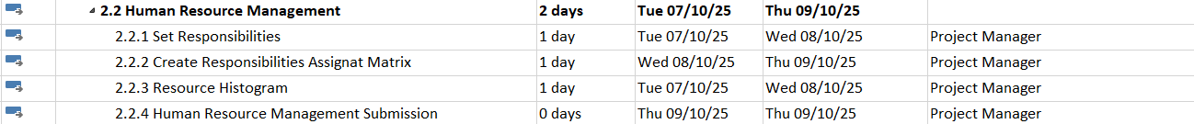

Figure 5 WBS - Human Resources Management Plan

Figure 6 WBS - Time Management Plan

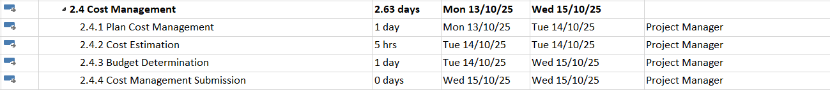

Figure 7 WBS - Cost Management Plan

Figure 8 WBS - Communication Management Plan



Figure 9 WBS - Procurement Management Plan

Figure 10 WBS - Quality Management Plan

Figure 11 WBS - Risk Management Plan

Figure 12 WBS - Execution overview Phases



Figure 13 WBS - Network Design & Planning phase



Figure 14 WBS - Network Implementation Phase



Figure 15 WBS - Security Implementation Phase



Figure 16 WBS - Server & Service Implementation Phase



Figure 17 WBS - End User Setup Phase

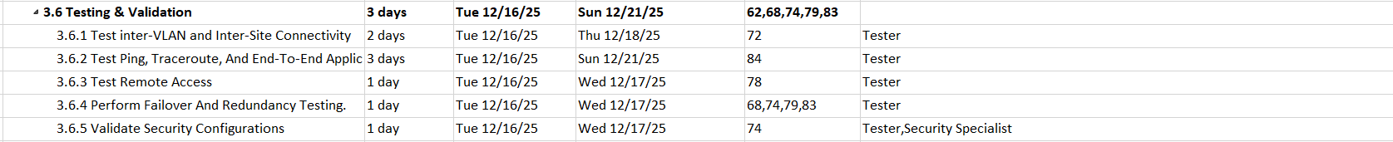

Figure 18 WBS - Testing & Validation Phase

Figure 19 WBS - Monitoring and Controlling Overview Phase

Figure 20 WBS - Project Closure Overview Phase

## Scope Verification:

The project deliverables must be fully functional network that contains VLAN, FTP, DNS, web DHCP and email services, BGP with route reflector, DMVPN, EIGRP and OSPF routing, and remote connectivity will be checked against the project requirements. For Each of the deliverable will be formally reviewed and signed off by the customer throughout the project lifecycle to ensure compliance and proper implementation.

Scope Control:   
To Continuously monitor the status of the project scope to confirm all planned deliverables such as network setup, VLAN, FTP, DNS, DHCP, web and email services, BGP, DMVPN, EIGRP, OSPF, and remote connectivity are being implemented as intended and functional. This section also defines the process for reviewing, approving, and documenting any changes to the scope baseline to prevent uncontrolled deviations.

# **Human Resource Management Plan**

## Introduction:

The selection, organization, and leadership of the project team are the main objectives of human resource management in order ensure effective task completion and goal achievement. All project participants are involved in preserving performance, accountability, and coordination.

### Human Resource Management Process:

To accomplish human resources management involve 4 main categories:

1. **Plan Human Resource Management:**

In the planning phase it involved defines how project roles, responsibilities, and reporting relationships will be structured.

1. **Assemble Project Team:**

The most suitable person for the project role is chosen at this phase. It involves allocating the appropriate individuals to the appropriate tasks by assessing team members according to their qualifications, experience, and availability for the role.

1. **Develop Project Team:**

The main objective of this procedure is building competencies, fostering improved collaboration, and increasing performance are.

1. **Manage the Project Team:**

Through this phase, team performance is tracked, disputes are settled to ensures continuous communication is maintained. The project manager oversees changes in responsibilities or assignments, assesses progress, and gives feedback.

### RACI

|  |  |  |  |
| --- | --- | --- | --- |
| Responsible | Accountable | Consulted | Informed |
| Project Manager | Project Manager | Client, Supervisor | Sponsor, Client |

Table 6 RACI - Human Resources Management Plan

## Human Management Approach:

### Responsibility Assignment Matrix (RAM):

This approach shows the task and Activities that are required for the execution phase of the project and shows the roles and responsibilities of the concern persons as well as training programs if required. This procedure can be done using Microsoft Excel tool.

### Visual Report:

#### Resource Work Summary Report and Resource Work availability:

This approach shows a report in visualise form for easy understanding the first one is Work Summary the report represents each person how much work they contribute to the project in hours. The secund report is Work availability in this report it highlights the work that has been done in the third and fourth quarter of the year 2025. All the report are exported from MS project.

## Reports:

### Responsibility Assignment Matrix:

The below table represent project tasks for the execution phase of the project. It also shows the skills required and the training if it required.

|  |  |  |  |  |  |  |
| --- | --- | --- | --- | --- | --- | --- |
| Task / Work Package / Activity | Skill required | Training Required | R | A | C | I |
| Design Network Topology and planning ip addressing | Network Design, IP Planning | yes | Network Designer | Project Manager | Network  Engineer | Security Specialist |
| Determine Network Segmentation | VLANs, Subnetting,  Security Policies | yes | Network Designer | Project Manager | Security Specialist | Network Engineer |
| Plan Routing Protocols | EIGRP, OSPFv3, BGP | no | Network Designer | Project Manager | Network Engineer | Security Specialist |
| Plan High-Availability Design | HSRP, Redundancy Concepts | yes | Network Designer | Project Manager | Network Engineer | Security Specialist |
| Configure Routers For WAN Connectivity and BGP. | WAN, BGP | no | Network Engineer | Project Manager | Network Designer | Security Specialist |
| Configure Routers For IGPs and Implement Redundancy Protocol (HSRP) | OSPFv3, HSRP, Route Redistribution | no | Network Engineer | Project Manager | Network Designer | Security Specialist |
| Configure Switches for VLAN Segmentation And Inter-VLAN Routing | VLAN, Trunking, Layer 3 Switching | no | Network Engineer | Project Manager | Network Designer | Security Specialist |
| Configure Routers For Role-Based Access and DMVPN For Secure Remote Connectivity | AAA, DMVPN, IPSec | yes | Security Specialist | Project Manager | Network Engineer | Network Designer |
| Configure Switches For Layer 2 Security | Port Security, BPDU Guard | yes | Security Specialist | Project Manager | Network Engineer | Network Designer |
| Configure Remote Access For Network Devices | SSH, telnet, AAA, RADIUS | no | Security Specialist | Project Manager | Network Engineer | Network Designer |
| Install And Configure Windows Servers | AD, DNS, DHCP, File Services | yes | System Administrator | Project Manager | Network Engineer | Security Specialist |
| Configure DNS with Load Balancing, Web, FTP, Email Servers, DHCP | DNS, Web Hosting | yes | System Administrator | Project Manager | Network Engineer | Security Specialist |
| Assign VLANs And IP Addresses To Endpoints | VLAN, DHCP | no | Network Engineer | Project Manager | System Administrator | Network Designer |
| Test inter-VLAN and Inter-Site Connectivity | Troubleshooting, Routing | no | Tester | Project Manager | Network Engineer | Security Specialist |
| Test Ping, Traceroute, And End-To-End Application Connectivity | End-to-End Troubleshooting | no | Tester | Project Manager | Network Engineer | Security Specialist |
| Test Remote Access | VPN, SSH, RDP Testing | no | Tester | Project Manager | Security Specialist | Network Engineer |
| Perform Failover And Redundancy Testing. | HSRP, Link Failure Scenarios | yes | Tester,  Security Specialist | Project Manager | Network Engineer | Security Specialist |
| Validate Security Configurations | ACLs, Firewall, AAA | yes | Tester,  Security Specialist | Project Manager | Network Engineer | System Administrator |

Table 7 Human Resources Management -Responsibility Assignment Matrix

### Resource Work Summary Report:

The below figure represents the work summary progress and the available work of the project. This report is representing the project team members and show how much available work, remaining work and the actual work the has been done for the individuals team members.

Figure 21 Human Resources Management - Resource Work Summary Report

### Resource Work availability Report:

the below figures show the resource availability it shows in two quarts the third and fourth of the year 2025 how much work available, how much remaining and how much work is done.

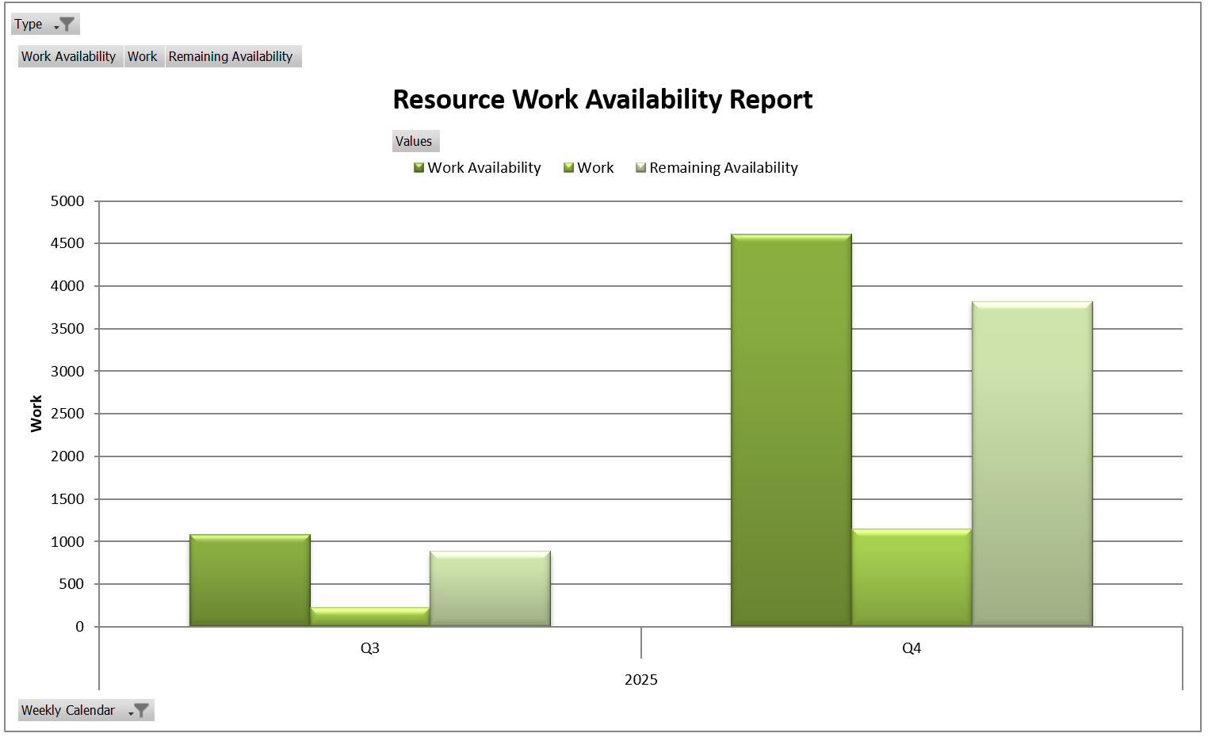

Figure 22 Human Resources Management - Resource Work availability Report

# **Time Management:**

## Introduction:

Project time Management or schedule management helps plan and control the time needed to finish GHN project task and deliver them on schedule. it includes creating timeline to list all the task with their duration and who is responsible for each. The plan also tracks the progress and sets actions if delay happens.

### Process:

Achieving the process of Time Management involves six main processes:

1. **Plan Schedule Management:**

The goal is to create a schedule management plan that defines how project activities will be developed, managed, and controlled throughout the project.

1. **Define Activities:**

Break down the main project work into smaller, tasks to make planning, tracking, and execution easier.

1. **Sequence Activities:**

In this phase identifies the relationships and dependencies between project tasks to determine the project’s critical path and available float time.

1. **Estimate Activity Durations:**

Estimate how long each task will take to complete in count to any lag time that may occur during the project’s implementation.

1. **Develop Schedule:**

Create the project realistic timeline by combining task durations, dependencies, and resources.

1. **Control Schedule:**

Monitoring the controlling any changes that may occur to the schedule, update the schedule, and take corrective actions when delays or changes occur

### RACI

|  |  |  |  |
| --- | --- | --- | --- |
| Responsible | Accountable | Consulted | Informed |
| Project Manager | Project Manager | Client, Supervisor | Sponsor, Client |

Table 8 RACI – Time Management Plan

## Schedule Management Approach:

To manage the project time the Microsoft tools below has been use:

* **Gantt Chart:**

it is a chart the display the task in hierarchal order. The diagram can show task dependency, duration and any leading or lagging time.

* **Dependencies:**

There is deferent type of dependencies:

1. Start-to-Start (SS)
2. Start-to-Finish (SF)
3. Finish-to-Start (FS)
4. Finish-to-Finish (FF)

it can be used to define predecessors and successors.

* **Network diagram:**

diagram that displays how tasks are connected.

## Changes:

To track GHN project progress at any time, Schedule Variance (SV) and Schedule Performance Index (SPI) are calculated during the schedule creation phase.

1. Schedule Variance (SV):

* When SV = 0, then the project is on schedule
* When SV > 1, then the project is ahead of schedule
* When SV < 1, then the project is behind schedule

1. Schedule Performance Index (SPI):

* When SPI = 1, then the project is on schedule
* When SPI $≥$ 1, then the project is ahead of schedule
* When SPI < 1, then the project is behind schedule

## Reports:

### Gantt chart:

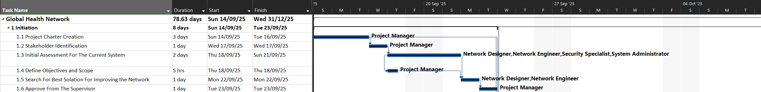The below Figures represent the Gantt chart for all the Phases of the Project with task the Start and Finish

Figure 23 Gantt Chart - Initiation phase

The below Figure represent Gantt Chart of the initiation Phase

The below Figure represent Gantt Chart of the Planning Phase Part 1

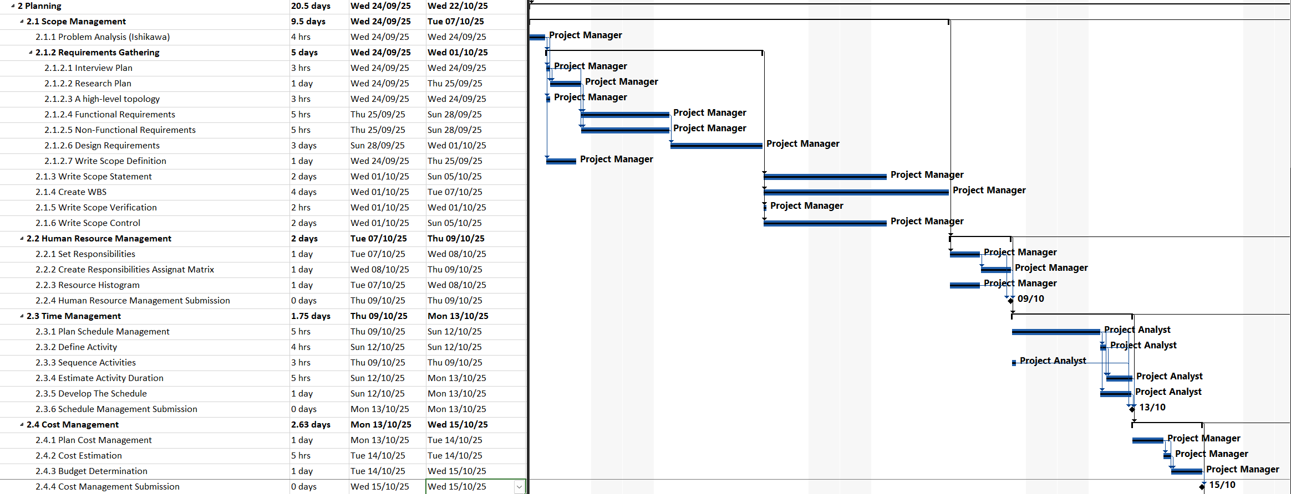

Figure 24 Gantt Chart - Planning phase Part 1

The below Figure represent Gantt Chart of the Planning Phase Part 2

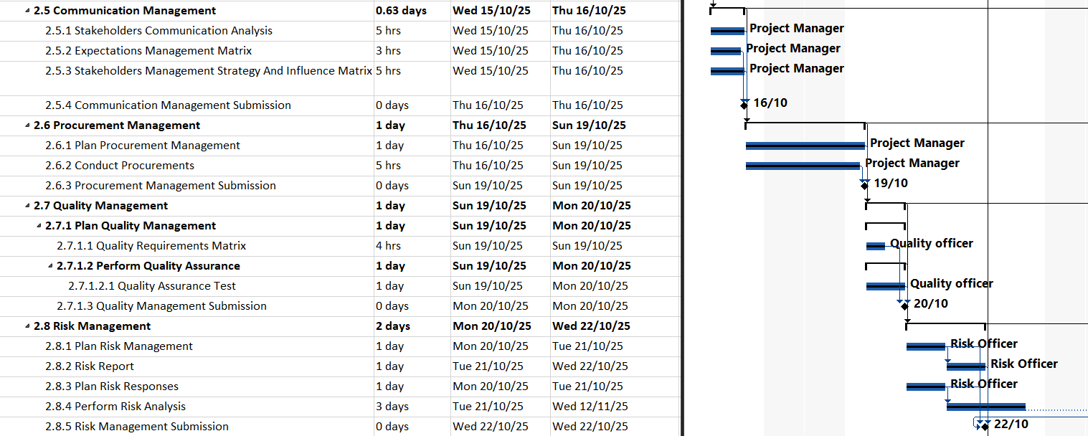

Figure 25 Gantt Chart - Planning Phase Part 2

The below Figure represent Gantt Chart of the Execution Phase Part 1

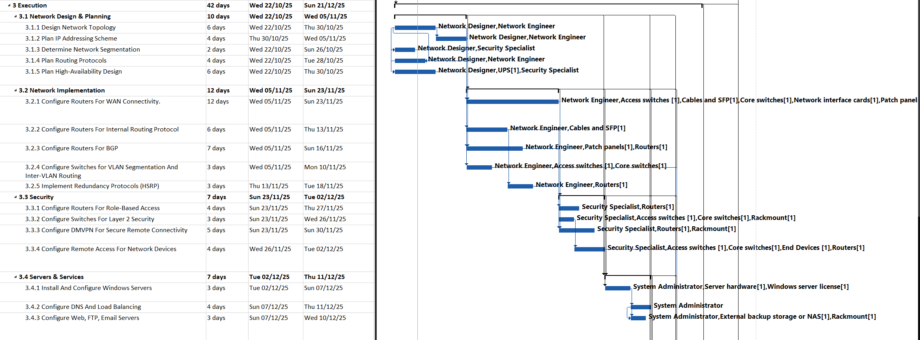

Figure 26 Gantt Chart - Excitation Phase Part 1

The below Figure represent Gantt Chart of the Execution Phase Part 2



Figure 27 Gantt Chart - Project closure Phase

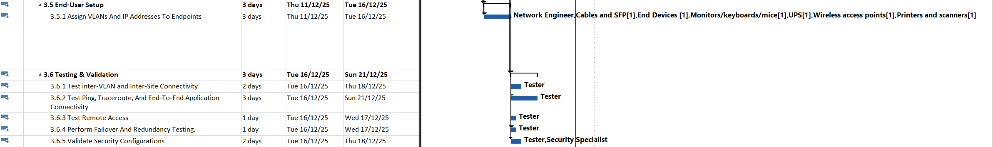

Figure 28 Gantt Chart - Execution Phase Part 2

The below Figure represent Gantt Chart of the Monitoring & Controlling Phase



Figure 29 Gantt Chart - Monitoring and Controlling Phase

The below Figure represent Gantt Chart of the Project Clouser Phase

### Network diagram:

Every task in the Gantt chart appears visually in the network diagram. It shows the time given for each work as well as the progress that has been assigned. Additionally, a milestone is accomplished at the conclusion of each crucial stage. Tasks are represented by a square, and milestones by a diamond. Red colored activities are incomplete, but blue colored jobs have been completed. Finding the project's critical path is the network diagram primary goal.

Figure 30 Network Diagram Overview Part 1

Figure 31 Network Diagram Overview Part 2

#### Initiation Phase:

The figures below show the Initiation of the Project in Network Diagram

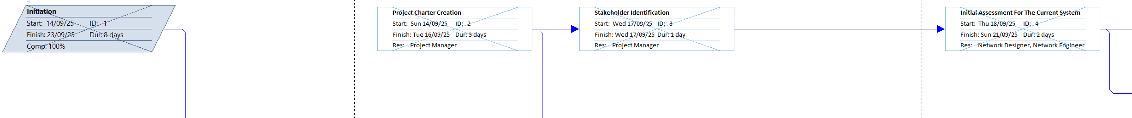

Figure 32 Network Diagram - Intiaiton Phase Part 1

Figure 33 Network Diagram - Initiation Phase Part 2

#### Planning Phase:

The figures below show the Planning of the Project in Network Diagram

Figure 34 Network Diagram - Planning Scope Management Phase Part 1

Figure 35 Network Diagram - Planning Scope Management Phase Part 2

Figure 36 Network Diagram - Planning Scop Management Phase Part 3

Figure 37 Network Diagram - Planning Scop Management Phase Part 4

Figure 38 Network Diagram - Planning Scop Management Phase Part 5

Figure 39 Network Diagram - Planning Human Resource Management Phase

Figure 40 Network Diagram - Planning Time Management Phase Part 1

Figure 41 Network Diagram - Planning Time Management Phase Part 2

Figure 42 Network Diagram - Planning Cost Management part 1

Figure 43 Network Diagram - Planning Cost Management Phase Part 2

Figure 44 Network Diagram - Planning Communication Management Phase

Figure 45 Network Diagram - Planning Procurement Phase

Figure 46 Network Diagram - Planning Quality Phase Part 1

Figure 47 Network Diagram - Planning Quality Phase Part 2

Figure 48 Network Diagram - Planning Risk Management Phase

#### Execution Phase:

The figures below show the Execution of the Project in Network Diagram

Figure 49 Network Diagram - Execution Network Design & Planning Part Phase 1

Figure 50 Network Diagram - Execution Network Design & Planning Phase Part 2

Figure 51 Network Diagram - Network Implementation Execution Phase

Figure 52 Network Diagram – Execution Security Phase

Figure 53 Network Diagram - Execution Phase - Server & Services

Figure 54 Network Diagram - Excitation End User Setup Phase

Figure 55 Network Diagram - Execution Test & Validations Phase

#### Monitoring & Planning Phase:

The figures below show the Monitoring & Planning of the Project in Network Diagram



Figure 56 Network Diagram - Monitoring & Planning Phase Part 1

Figure 57 Network Diagram - Monitoring & Planning Phase Part 2

#### Project Closure Phase:

The figures below show the Project Closure of the Project in Network Diagram

Figure 58 Network Diagram - Project Closure Phase Part 1

Figure 59 Network Diagram - Project Closure Phase Part 2

Figure 60 Network Diagram - Project Closure Phase Part 3

### Baseline Report:

The diagram below of a baseline report. It shows the overall cost of each baseline in the project's work breakdown structure (WBS) and shows the work and baseline structure of the five processes. As a result, this report is helpful in managing and moderating the project's work scheduling process while keeping an eye on changes to the baseline cost.

Figure 61 Baseline Report

### Critical Task Status Report:

The diagram below of Critical Task Status Report. This report shows the critical tasks status of the main five processes of the project is gives the work progress and the remaining work for the project activities. Furthermore, the Report shows separate tasks into critical and non-critical tasks. This report helps the project manager to focuses on knowing the cortical tasks that need to be completed without and delay.

Figure 62 Critical Task Status Report

### Schedule Performance Index and Schedule Variance report:

the below figure included two columns SV (Schedule Variance) and SPI (Scheduled Performance Index). These columns help in representing changes in the activities progress as they define late or early schedule progress.

The below Figure represent SV and SPI of the initiation Phase

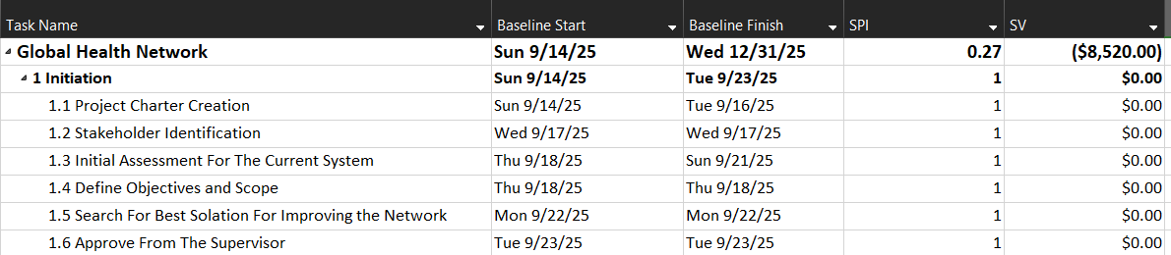

Figure 63 Baseline Schedule - Initiation Phase

The below Figure represent SV and SPI of the Planning Phase Part 1

Figure 64 Baseline Schedule - Planning Phase Part 1

The below Figure represent SV and SPI of the Planning Phase Part 2

Figure 65 Baseline Schedule - Planning Phase Part 2

The below Figure represent SV and SPI of the Execution Phase

Figure 66 Baseline Schedule - Execution Phase

The below Figure represent SV and SPI of the Monitoring and Controlling Phase

Figure 67 Baseline Schedule - Monitoring & Controlling Phase

The below Figure represent SV and SPI of the Project Clouser Phase

Figure 68 Baseline Schedule - Project Closure Phase

# **Cost Management:**

## Introduction:

Project time management focuses on all the project tasks and deliverables to be within the determined budget. It has planning, estimating, and controlling the project cost to make sure the project is alien with the project budget.

### Process:

Achieving the process of Cost Management involves four main processes:

1. **Plan Cost Management:**

The goal is to create a cost management plan that defines how project task will be estimated, budgeted, managed, monitored, and controlled throughout the project.

1. **Estimate Costs:**

This proses involved calculating financial resources needed for each project activity. It involved labour, network equipment and other related costs.

1. **Determine Budget:**

In this phase creates a feasible cost baseline by combining the projected expenses of several tasks or tasks. It outlines the amount of money needed and offers a baseline for evaluating the accomplishment of the project.

1. **Cost control:**

This procedure continually keeps watch on project expenses to make certain they stay within the approved expense limit. It entails monitoring cost performance, spotting errors, and controlling modifications to the cost baseline.

### RACI

|  |  |  |  |
| --- | --- | --- | --- |
| Responsible | Accountable | Consulted | Informed |
| Project Manager,  Project Analyst | Project Manager | Client, Supervisor | Sponsor, Client |

Table 9 RACI - Cost Management Plan

## Cost Management Approach:

To manage the project time the Microsoft tools below has been use:

* **Microsoft Project Resource sheet:**

Microsoft Project has been utilized to create the project’s resource sheet which document all the required resources required to finish the project. In addition, the resources sheet calculates the cost of each resource based on the rate, type of the resource and the time each resource has been working

* **Microsoft Excel Cost Benefit Analysis:**

The approximate payback period and the breakeven period are calculated by the cost-benefit analysis based on the net present value.

## Changes:

To track GHN project progress at any time, Cost Variance (CV) and Cost Performance Index (CPI) are calculated during the cost creation phase.

1. Cost Variance (SV):

* When CV = 0, then the project is on schedule
* When CV > 1, then the project is ahead of schedule
* When CV < 1, then the project is behind schedule

1. Cost Performance Index (CPI):

* When CPI = 1, then the project is on schedule
* When CPI > 1, then the project is ahead of schedule
* When CPI < 1, then the project is behind schedule

## Report:

### Resource sheet - Entry View:

The figure below represents the Resource sheet entry views where all the resources and the material have been given cost estimation

Figure 69 Resource sheet - Entry View

### Resource Sheet – Cost View

The Figure below represent the Cost view in the Resource sheet. It shows all the material and the people will cost for the project.

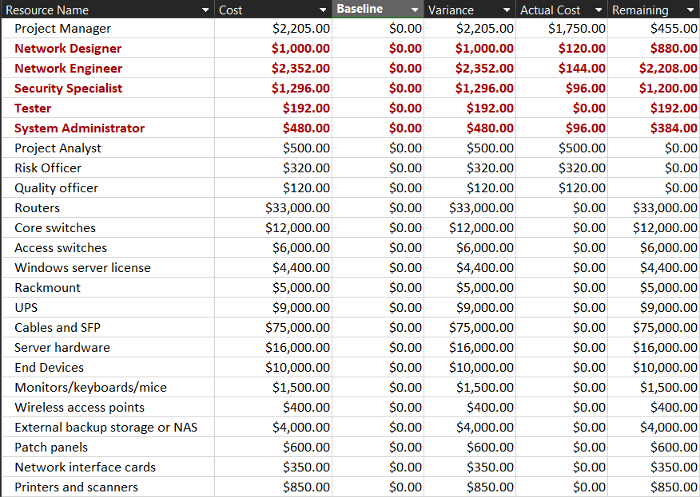

Figure 70 Resource Sheet – Cost View

### Cost Variance and Cost Performance Index

The figures below show CV (Cost Variance) and CPI (Cost Performance Index). These help in representing cost changes in the activities as they define overrunning or maintaining within the budget.

The following figure displays the cost of the project in initiation phase

Figure 71 Baseline Cost - Initiation Phase

The following figure displays the cost of the project in planning phase Part 1

Figure 72 Baseline Cost - Planning Phase Part 1

The following figure displays the cost of the Project in Planning phase Part 2

Figure 73 Baseline Cost - Planning Phase Part 2

The following figure displays the cost of the project in Execution phase part 1

Figure 74 Baseline Cost - Execution Phase Part 1

The following figure displays the cost of the project in Execution phase part 2

Figure 75 Baseline Cost - Execution Phase part 2

The following figure displays the cost of the project in Monitoring and controlling phase

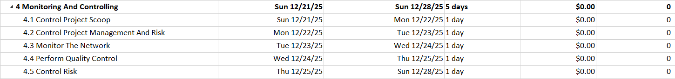

Figure 76 Baseline Cost - Monitoring and controlling Phase

The following figure displays the cost of the project in Project Clouser phase

Figure 77 Baseline Cost - Project Clouser Phase

### Budget Cost Report:

The following figure includes a bar chart that shows the used budget for the entire project life cycle. Because of the many project tasks that took place in the fourth quarter of 2025, it shows from the bar chart that the cost has increased in comparison to other quarters. Furthermore, this report helps the project manager in visualizing the baseline cost and actual cost.

Figure 78 Budget Cost Report

### Baseline Cost Report:

The below figure show the Baseline cost report this figure show the baseline and the actual cost of the process that helps the project manager visualize how the project budget is used through the project implementation phase.

Figure 79 Baseline Cost Report

### Cost-Benefit Analysis Report:

The below figure shows the calculation of the net present value (NVP) of the project in 6 years. This report include determent the project cost and financial outcomes to calculate the total benefit and the payback period that can be estimated from the NVP.

Figure 80 Cost-Benefit Analysis

### Payback Period

The below figure shows the steps to how to calculate the payback period of the project using the NVP. The payback period is the period where all the project outcome cost starts to bay itself and the client benefit from it.

Figure 81 Cost-Benefit Analysis - Payback Period

The below figure shows the payback Period in graph format for easily understanding

Figure 82 Cost-Benefit Analysis - Payback Period Graph

# **Communication Management:**

## Introduction

Communication management are the group of techniques used to check project data if it has been planned, created, supervised, and sent to team members and stakeholders in a detailed and relevant manner. To ensure alignment, collaboration, and well reasoned decision making throughout the project lifecycle, effective communication management establishes a clear conduit between stakeholders from deferent departments, positions, and organizational backgrounds.

### Processes:

Achieving the objectives of Communication Management involves five main processes:

1. **Bringing Stakeholders Together:**

Encourage cooperation between deferent department like management, security, and IT departments.

1. **Talking About Problems:**

The difficulties in the project are brought up as soon as possible.

1. **Information Reception and Transmission:**

Share updates on project status, security protocols, and network configurations.

1. **Control and Manage Communication Techniques:**

Keep the right networks open for documentation, notifications, and reporting.

1. **Assure Team Members' Effectiveness:**

Make sure that everyone on the team know of their roles, duties, and deadlines.

### RACI

|  |  |  |  |
| --- | --- | --- | --- |
| Responsible | Accountable | Consulted | Informed |
| Project Manager | Project Manager | Client, Supervisor | Sponsor, Client |

Figure 83 RACI - Communication Management Plan

## Communication Approach:

To execute a successful Communication Management Plan for the GHN project, a number of techniques were used:

1. **Stakeholder Communications Analysis:**

This strategy offers an organized way to handle project communications. It makes sure every person involved including the project team, management, and outside partners is informed on the details essential to their jobs and duties. It assists in determining which communication method each stakeholder prefers, how often they need information, and what kind of information they need.

1. **Expectations Management Matrix:**

Stakeholder expectations about project deliverables, network performance, security requirements, timetable fulfilment, and financial restrictions are identified and documented using this approach. To minimize errors and improve stakeholder satisfaction, these expectations are ranked in a matrix to guarantee that the most important criteria are fulfilled first.

1. **Stakeholders Management Strategy and Influence Matrix:**

This method finds important stakeholders and assesses their degree of interest and impact on the GHN project. The project team may modify communication tactics to successfully engage important stakeholders and guarantee that their issues are swiftly addressed stakeholders effectively and ensure their concerns are addressed promptly.

## Reports:

### Stakeholder Communication Analysis:

The table which follows provides a reliable examination of stakeholder and project manager communication. The necessary parties are guaranteed to be aware of problems and fields of interest. The who, what, and when are displayed in the table below.

|  |  |  |  |
| --- | --- | --- | --- |
| **Stakeholder** | **What need to be communicated** | **Format/method** | **Due** |
| **Supervisor, Client** | **Weekly Meetings** | **Meeting via Microsoft teams** | **Every week, Wednesday from 12:30-1:00 PM** |
| **Supervisor, client** | **Charter** | **Submission via Bahrain Polytechnic Moodle, the submission is in PDF format.** | **November $4^{th}$ Final plan document summation** |
| **Supervisor, client** | **Plan** | **Submission via Bahrain Polytechnic Moodle, the submission is in PDF format.** | **November $4^{th}$ Final plan document summation** |
| **Supervisor, client** | **Design Document** | **Submission via Bahrain Polytechnic Moodle, the submission is in PDF format.** | **Week 8 Design Document summation** |
| **Supervisor, client** | **Thesis Document** | **Submission via Bahrain Polytechnic Moodle, the submission is in PDF format.** | **December ${28}^{th}$ Final Thesis document summation** |
| **Supervisor, client** | **Product** | **Submission via Bahrain Polytechnic Moodle, the submission is in Zip format.** | **December ${28}^{th}$ Final product summation** |
| **Supervisor, client** | **Demonstration** | **The demonstration will be conducted physically (face- face)** | **December ${28}^{th}$ Final Demonstration** |

Table 10 Stakeholder Communication Analysis

### Expectations Management Matrix

The requirements of stakeholders on several aspects of project success measurement, including time, budget, quality, customer acceptability, and project scope, are shown in the table below. From that, these measures are prioritized according to the project's constraints, and the level of stakeholder need where 1 is the lowest and 5 is the highest.

|  |  |  |
| --- | --- | --- |
| **Measure of Success** | **Priority (1-5)** | **Stakeholders Expectations** |
| **Time** | 3 | Submition of the final product before on time. |
| **Budget** | 4 | All the project development within the budget that has been set. |
| **Quality** | 4 | The client demands very Hight quality result to meet the quality and industry standards. |
| **Scope** | 4 | The project must meet all the scope requirement to satisfy the client |
| **Customer Acceptance** | 4 | How the product and work progresses must satisfy the client. |

Table 11 Expectations Management Matrix

### Stakeholders Management Strategy and Influence Matrix

A list of important individuals with an interest in the project is shown in the table below. It also demonstrates the possible impact and input different stakeholders might have given to the project.

|  |  |  |  |  |
| --- | --- | --- | --- | --- |
| **Stakeholder** | **Role** | **Internal** | **Level of Interest**  **HML** | **Potential Management Strategy** |
| Dr. Ayman Alani | Supervisor | Internal | H | Provide supervision and advice via conducting weekly meetings and emails. |
| Husain Ali | Project Manager,  Network Designer/Architect,  Network Engineer,  Security Specialist,  Tester,  System Administrator,  Project Analyst,  Risk Officer,  Quality officer | Internal | H | Manage and supervise all project phases based on the information received from client and supervisor. |

Table 12 Stakeholders Management Strategy and Influence Matrix

# **Procurement Management:**

## Introduction

Procurement management are the procedures needed to obtain the products and services from outside suppliers within the determined budget.

### Processes

Achieving the objectives of procurement Management involves four main processes:

1. **Plan Procurement Management**

This process entails determining whether products or services need to be acquired from sources outside of the company. It involves selecting the contract type, creating specifications, and specifying procurement needs. Making ensuring that every procurement activity complies with project goals and budget constraints is the main purpose.

1. **Conducting Procurements**

This phase is focused on getting offers or proposals from the suppliers, assessing them, and choosing the most suitable one. It includes drafting, settling on terms, and giving out contracts.

1. **Monitoring and Controlling Procurements**

This procedure guarantees that everyone fulfills their responsibilities. It involves tracking vendor performance, handling changes or problems, and confirming that deliverables satisfy deadline and quality standards.

1. **Closing Procurements**

Contracts are formally completed and finalized during this last step. It entails confirming receipt of all deliverables, payment settlement, and documentation of assessments of performance.

### RACI

|  |  |  |  |
| --- | --- | --- | --- |
| Responsible | Accountable | Consulted | Informed |
| Project Manager,  Project analyst | Project Manager | Client, Supervisor | Sponsor, Client |

Table 13 RACI - Procurement Management Plan

## Procurement approach

To execute a successful Procurement Management for the GHN project, structured approach was used:

1. **Budgeting:** calculating out the project's overall budget, selecting the products and services that require purchase, and creating the requisite.
2. **Maintaining lists of Items and Suppliers:** create a list of the suppliers and the item they offer.
3. **Requesting for Quotation:** submit theorder for approval
4. **Place Order:** placing the order and approving the purchase.

# **Quality Management:**

## Introduction:

Quality management plan is the process to ensure that all the project deliverables meet the standers, requirements and stakeholder expectations. It creates a structure for keeping efficiency, dependability, and consistency across the duration of the project. Error prevention, early problem detection, and ongoing process and result quality improvement are the primary objectives of the plan.

### Processes:

Achieving the process of Quality Management involves three main processes:

1. **Plan Quality Management:**

To create a quality management plan that defines standards and quality measures that the project must meet. Also identify the tools, methods, and metrics that will be used to measure quality.

1. **Quality Assurance:**

Responsible for verifying that the specific quality standards and satisfy the needs of the clients by auditing and analysing the quality requirements and quality control measurements.

1. **Quality control:**

Responsible for monitoring and controlling project results to make sure that they meet with industry standards.

### RACI

|  |  |  |  |
| --- | --- | --- | --- |
| Responsible | Accountable | Consulted | Informed |
| Project Manager,  Quality officer | Project Manager | Client, Supervisor | Sponsor, Client |

Table 14 RACI - Quality Management Plan

## Quality Management Approach:

### Approach:

Several approaches used throughout project to follow the quality management strategy

1. **PIECES Framework:**

It is a framework used to analyze and improve business processes. I help to identify problems and areas for enhancement by focusing on six key dimensions:

* **P**erformance: Analyze the efficiency of the existing operation or system.
* **I**nformation: Analyze the information's timeliness, accuracy, and relevance.
* **E**conomy: Analyze how cost-effective the procedure or system are.
* **C**ontrol: Analyze the effectiveness of internal controls, security, and compliance.
* **E**fficiency: Pay close attention to the efficient use of resources (staff, money, and time).
* **S**ervice: Analyze how well stakeholders are supported by the system or procedure.

1. **Quality Assurance:**

Involves verifying that the specific quality standards and satisfy the needs of the clients to deliver hight quality product.

1. **Quality Control:**

Monitoring and controlling tasks to meet the required stander and Performing test on the system during the development process to ensure industry standards.

### Test case:

The below table represent the list of cases scheduled for future testing to measure and maintain the standards of the project quality.

|  |  |  |  |  |  |
| --- | --- | --- | --- | --- | --- |
| **No.** | **Function Tested** | **Test Case Description** | **EXPECTED RESULTS** | **ACTUAL RESULTS** | **PASS /FAIL** |
| 1 | FTP server | The user can use the FTP server to upload and download files from the shard folder | The FTP Server works by allowing users to upload and download over the internet. | - | Not Tested |
| 2 | DNS load balancing | The user should not be affected if the DNS server goes down | When the primary DNS server goes down, the backup DNS server takes over control. | - | Not Tested |
| 3 | Communication between deferent | Each department is isolated in its own VLAN. For departments to communicate with each other, inter-VLAN routing must be enabled. | Devices from deferent department can communicate with each other | - | Not Tested |
| 4 | Web server | The web server must be up and running at all times. | The web server is working | - | Not Tested |
| 5 | DMVPN | Each site communicates with the others using a VPN to enhance security | The DMVPN is operational at every site. | - | Not Tested |
| 6 | Remote access to the network | The network must have remote access enabled | SSH/Telnet is operational in the network. | - | Not Tested |

Table 15 Quality - Test Case

## Report

### Quality Requirement Matrix

The below table list qualities and metrics requirements that follow PIECES approach, along with their sources. This list shows that the requirements are being followed and carried out during the execution phase to guarantee that the final product satisfies client and industry standards.

|  |  |  |  |
| --- | --- | --- | --- |
| **No.** | **Standard Source** | **Requirements including**  **Standard and metric(s)** | **Achieved / Not Achieved** |
| 1 | Brief | The network must support stable HD video calls with latency below 150 ms | Not achieved |
| 2 | Research | The network configurations must follow standardized template for naming device for simple maintenance | Not achieved |
| 3 | Client | The DMVPN design must encryption to protect data across WAN tunnels. | Not achieved |
| 4 | Research | The network must support adding new sites with minimum configuration changes and disturbance to the network. | Not achieved |
| 5 | Client | The network must have remote access services enabled using ssh and telnet | Not achieved |
| 6 | Brief | The network must host FTP server. | Not achieved |
| 7 | Brief | The network must host DNS. | Not achieved |
| 8 | Brief | The network must host web server | Not achieved |
| 9 | Brief | The network must have Power saving features to reduce energy use during off peak hours. | Not achieved |
| 10 | Research | The network must have Summarization to reduce unnecessary advertisements across WAN | Not achieved |
| 11 | Research | The network must have role based access to limit configuration privileges on network devices | Not achieved |
| 12 | Brief | The network must have redundancy for minimal down time | Not achieved |
| 13 | client | The network must have protective measures for vlan security and other attacks | Not achieved |
| 14 | Client | The network must have redundancy default gateway for less down time | Not achieved |
| 15 | Brief | The network uptime must be at 95% availability | Not achieved |

Table 16 Quality Requirement Matrix

# **Risk Management:**

## Introduction:

Risk management planning is the process of analyzing and responding to potential risks throughout the project lifecycle that may affect the project deliverables. Its goal is to minimize potential threats and take advantage of opportunities.

### Process:

Achieving the process of risk management involves four main processes:

1. **Plan Risk Management:**

To produce an organized plan for recognizing, monitoring, and mitigating risks. This procedure explains the strategies, resources, including roles for risk management during the project.

1. **Identify Risks:**

To pinpoint possible external and internal vulnerabilities that can compromise the project's goals. This involves getting insight from stakeholders and team members in order to create an extensive risk registry.

1. **Perform Risk Analysis:**

To rate each learned risk's effect and potential. This stage aids in prioritizing which threats may be tracked over time as well as which need to be corrected right away.

1. **Plan Risk Responses:**

To establish plans to act and strategies to deal with any major danger. Depending on risk potential, possible responses include acknowledging, transferring, avoiding, or mitigating it.

1. **Monitor and Control Risk:**

To keep eye on risks that have been recognized, identify unexpected ones, and assess how well mitigation strategies are working. As the project expands, changes are made to ensure that risks are kept under control.

### RACI

|  |  |  |  |
| --- | --- | --- | --- |
| Responsible | Accountable | Consulted | Informed |
| Project Manager,  Risk officer | Project Manager | Client, Supervisor | Sponsor, Client |

Table 17 RACI - Risk Management

## Risk Management Approach:

### Approach:

Several approaches used throughout project to follow the risk management strategy:

**1. PESTEL framework:**

The PESTEL framework is broken down into six factors Political, Economic, Social, Technological, Environmental, and Legal factors. It’s used to analyze the external environment that can impact a project or organization

**2. PPMMEE Framework:**

The PPMMEE framework is broken down into six factors People, Process, Money, Materials, Equipment, and Environment. It’s used to analyze internal factors that affect project performance

## Risk Register:

### Report

The below table shows the potential risks in the project keep in mind the potential issues that might affect the project success. This list gathers different types of potential risks and presents their possibility of occurrence and impacts as well as provide a mitigation procedure with the person who is responsible as a way of handling these issues.

|  |  |  |  |  |  |  |  |  |
| --- | --- | --- | --- | --- | --- | --- | --- | --- |
| **No.** | **Responsible** | **Risk** | **Category** | **Probability (HML)** | **Impact**  **(HML)** | **Level P*I** | **Mitigation** | **Status** |
| 1 | Security Specialist | The VPN does not encrypt the traffic between sites | Functional | H | H | H | Check the source of the problem and resolve it. | Open |
| 2 | Security Specialist | any user has privilege level 15 access | Functional | L | H | M | Check Role-based access control configuration | Open |
| 3 | Network Designer | Long down time due to link or device failure | nonfunctional | M | H | H | Conduct a meeting with the network designer to fully resolve the issue. | Open |
| 4 | Network Designer | the network does not meet the client design requirement | Technical | L | M | M | Conduct a meeting with the client to redesign the network to meet the requirement | Open |
| 5 | Project manager | Fail to deliver the project on time | Technical | M | H | H | Create a detailed time schedule to track the progress of tasks effectively. | Open |
| 6 | System Administrator | Can’t send or receive any document between sites | Functional | M | H | H | Check the FTP server for any issues and resolve it. | Open |
| 7 | System Administrator | There is no automatic backup for the data. | Nonfunctional | M | H | H | Check the configuration for the cloud backup servers and NAS | Open |
| 8 | Project manager | Exceeding the budget | Technical | M | H | H | Document the estimated time for each task, including potential extensions if needed. | Open |
| 9 | Network engineer, Security Specialist | The network does not meet industry standards | Legal | L | H | M | construct a plan that details how the network will incorporate industry standards and follow them | Open |
| 10 | Network engineer | The departments cannot communicate with each other | Functional | M | M | M | Check the inter-vlan configuration | Open |
| 11 | System Administrator | Can not access the web server using the DNS name | Functional, Technical | M | H | H | Check the load balancing for the DNS server to ensure that the backup DNS is working | Open |
| 12 | Security Specialist | The network could be attacked at layer 2 | Functional | M | H | H | The network specialist must implement security at layer 2 | Open |
| 13 | Project manager | Potential for legal issue | legal | M | H | H | The project manager must have knowledge about rules and regulations | Open |
| 14 | Tester | The email server is not working | Functional | M | H | H | The tester must check all the servers to insure they are working | Open |
| 15 | Network engineer, tester | Failure to access the network remotely. | Functional | M | H | H | The network engineer must implement remote access for outside workers, and it must be tested multiple times | Open |

Table 18 Risk Register Report

# **Integration Management Plan and Closing Plan:**

## Introduction:

Integration management plan is the is the process to ensure coordination and keep everything connected. it ensures that scope, schedule, cost, quality, communication, risks, and resources don’t operate separately but are managed as one unified project.

## Approach:

Achieving the process of risk management involves six main processes:

1. **Develop the Project Charter:**

This process involves defining objectives that contain the overview and guidelines of the system that approves project initiation.

1. **Develop Project Management Plan:**

This process involves develops an organized and robust project management strategy by coordinating all management planning steps.

1. **Direct and manage project:**

In this process concluding the project according to schedule. To develop the deliverables, the project manager is responsible for organizing tasks, personnel, and resources.

1. **Monitor and control the project:**

managing the company on an everyday basis, ensuring quality requirements are fulfilled, and fixing any problems that arise during operation. Frequent monitoring ensures that goals are reached while preserving control over the project's duration, cost, and scope.

1. **Perform Integrated Change Control**

This phase verifies that every change request has been thoroughly examined, assessed, and approved. By stopping unauthorized modifications, it preserves the stability of the project. Modifications that have been approved are shared and reflected in the updated in project plan.

1. **Close Project:**

At this stage, all tasks associated with the project are officially finished. Deliverables are check it, approved, and given to the sponsor or client. The project team makes sure that all contracts are properly closed, releases resources, and completes reports.

### RACI

|  |  |  |  |
| --- | --- | --- | --- |
| Responsible | Accountable | Consulted | Informed |
| Project Manager,  Project analyst | Project Manager | Client, Supervisor | Sponsor, Client |

Table 19 RACI - Integration Management Plan and Closing Plan

## Reports:

The below table represent the project manager list to ensure the project meet the client expectation and requirement.

|  |  |  |
| --- | --- | --- |
| **No.** | **Criteria** | **Achieved** |
| 1 | Functional and nonfunctional requirement have been achieved | Y / N |
| 2 | Fully functional network for GHN | Y / N |
| 3 | client and supervisor has been met | Y / N |
| 4 | project documents such as project charter, project plan, thesis, network design are submitted | Y / N |
| 5 | close the project by submitting project closure checklist. | Y / N |

Table 20 Integration Management Report

# **Legal, Ethical, Social and Professional Issues (LESPI)**

### Potential Legal Issues

According to Bahrain’s Personal Data Protection Law No. (30) of 2018, Global Health Network must not disclose any patient’s personal data to the public and must comply with strict legal frameworks such as HIPAA and GDPR to maintain patient confidentiality. Therefore, as the Project Manager for Global Health Network, I will ensure that the project strictly adheres to data protection best practices, implementing robust security controls and privacy measures to safeguard all patient information.

### Potential Ethical Issues

The project must protect sensitive patient data and ensure the IT system is used only for its intended healthcare purpose and not to train any kind of Artificial intelligence.

### Potential Social Issues

The introduction of a new network infrastructure may object to the upgrading to a new network because they are unfamiliar with it and the process of tanning the staff may temporarily disrupt the workflow.

### Potential Professional Issues

From the professional standpoint the project must adherence to ICT best practice, commitment to information security standers and obligation to provide a solution that improves the healthcare regather than causes disruption with them.

# **Approval Signatures**

The signatures of the people below document acceptance and approval of the formal project charter. The sponsor representative must have the authority to commit the client’s resources to the project. The project manager is empowered by this charter to proceed with the project as outlined in the charter.

|  |  |  |
| --- | --- | --- |
| Position/Title | Signature | Date |
| Project Manager | Husain Ali | 1/11/2025 |
| Project manager office |  |  |

Table 21 Approval Signatures

# **Appendices**

## **Appendix 1: Problem Analysis**

### Ishikawa diagram:

The Ishikawa diagram shows the main reasons why GHN WAN infrastructure isn't reliable. It helps find problems in four areas: People, Processes, Technology, and Environment. This diagram also shows what problem needs to be solved and how to show it to the people who need to know about it.

Figure 84 Appendix 1 - Ishikawa diagram

## **Appendix 2: Requirements Gathering & Analysis**

### Interview Plan

An interview took place with the client. The table below shows the questions and answers from the interview analysis, as well as the results.

|  |  |
| --- | --- |
| **PROJECT No. and Title:** Project 21 - CCNP Route For a Global Health Network | **PROJECT MANAGER:** Husain Ali |
| **DATE CREATED: 5/10/2025** | **DATE LAST UPDATED:** 1/11/2025 |
| **Interview Date and Time:** 8/10/2025 - 12:30 PM | **Interviewee:** Dr. Ayman Alani |

|  |  |  |
| --- | --- | --- |
| **Question** | **Answer** | **Requirement** |
| What type of routing protocols does the new network implement? | Must implement OSPF and EIGRP | Implement OSPF & EIGRP |
| How will sensitive health data be protected during transmission? | Use DMVPN VPN to ensure encryption and scalability | Implement DMVPN phase 3 |
| How will external and remote users get access to the network? | Use telnet of SSH for remote access | Configure telnet or SSH in devices |
| What is the most secure method for sending and receiving files between sites? | Use SFTP or FTP to make sure both end-users can send and receive files | Configure SFTP or FTP |
| What security measures the network will have in place | Make sure you have layer2 security measure and for deferent type of attacks like vlan spoofing | Implement layer 2 security |
| what should be done about resources being overused  follow -up:  how to conserve power to minimize costs? | Make sure that if there are no heavy users on the network the routers enable power saving feature | Turen off unused interface and turn off POE ports unused |
| How many DNS server dose the GHN need | It must have at least one active and one stand by | Must implement load balancing for the DNS |

Table 22 Appendix 2 - Interview Plan

### Research Plan

Performing research plan to gather information and help with the client need and requirement. The below table represent the requirement to the project with the references.

|  |  |
| --- | --- |
| **PROJECT No. and Title:** Project 21 - CCNP Route For A Global Health Network | **PROJECT MANAGER:** Husain Ali |
| **DATE CREATED:** 10/10/2025 | **DATE LAST UPDATED:** 1/11/2025 |

|  |  |  |
| --- | --- | --- |
| **Research Topic** | **Findings and Reference (APA)** | **Requirement** |
| Technology (What are the expected integration requirements with current system?) | | |
| What is the best network topology for this solution? | Deferent types of topology design  (GeeksforGeeks, 2017) | Choose the best network topology that will work for now and for future upgrade |
| why choose BGP to manage routing between international sites and using best Practices in Route Redistribution? | BGP overview and route redistribution explanation  (Staff, 2024)  (Molenaar, 2013)  (PyNet Labs, 2023) | Using BGP and Route Redistribution for communication between deferent routing protocols |
| HD video requirement over WAN | latency should be ≤ 150 ms and bandwidth requirement 720p HD ~1.2-2.5 Mbps, for 1080p HD ~3-4 Mbps upstream/downstream per stream  (aonmeetings,2025) | The latency should be less than 150 and high bandwidth |
| Role based for deferent type of users | Cisco has its own Role-Based CLI Access  (Cisco, n.d.) | Implement cisco Role-Based CLI Access |
| the reason for using route summarization | reduces routing tables and minimizes routing update message volume between routers.  (jumpcloud, 2025) | Implementing route summarization where it needs to be |
| What type of VPN will be used | DMVPN passe 3 is the best choice for the network requirement  (cisco, 2019) | Implementing DMVPN phase 3 |
| Operational Analysis (How day to day operations will be handled) | | |
| Best practice for handling backup? | Follow the rule 3 2 2  (Arcserve, 2020) | Back up the data off site |
| Naming Device Naming Conventions | How Device Naming Conventions Work and the benefit of it  (Davis, n.d.) | follow standardized template for naming device |

Table 23 Appendix 2 - Research Plan

A high-level topology

The below diagram shows draft of network topology that will be implemented for Global health network

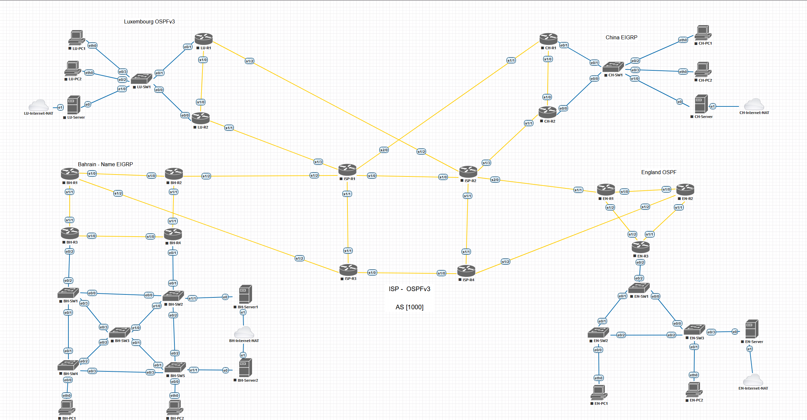

Figure 85 Appendix 2 - A high-level topology

### Functional Requirements

The Table below is a list for the functional requirements essential to fulfill the project scope and objectives. The specifications are produced using data from the client, project brief, and research.

|  |  |  |  |  |  |  |  |
| --- | --- | --- | --- | --- | --- | --- | --- |
| **No.** | **Source**  Brief/Client  /Research | **Requirement Description** | **Data** | **Process** | **Communication** | **Priority**  **H/M/L** | **Status** |
| Req1 | Brief | The network must host FTP server. | 🗸 | - | 🗸 | H | - |
| Req2 | Brief | The network must host DNS. | 🗸 | - | - | H | - |
| Req3 | Research | The WAN must use BGP to manage routing between international sites | - | - | 🗸 | H | - |
| Req4 | Client | The network must implement advance routing protocols using EIGRP and OSPF | - | - | 🗸 | H | - |
| Req5 | Research | The network must allow route redistribution between different routing protocols and BGP where is required | - | - | 🗸 | H | - |
| Req6 | Brief | The network must host Web server. | 🗸 | - | - | H | - |
| Req7 | Client | The network must establish secure WAN between branches using DMVPN phase 3 | 🗸 | 🗸 | - | H | - |
| Req8 | Research | Role based access must be implemented to limit configuration privileges on network devices | 🗸 | 🗸 | - | H | - |
| Req9 | Brief | The WAN design must include redundancy to prevent service disruption. | - | 🗸 | 🗸 | H | - |
| Req10 | Client | The network must use DHCP server | 🗸 | - | - | H | - |
| Req11 | client | The network must use hierarchical and scalable IP addressing scheme for GNH growing | - | - | 🗸 | M | - |
| Req12 | Client | The vlan segmentation ensured secure and safe environment any attack happened | - | 🗸 | - | H | - |
| Req13 | Research | Summarization must be configured to reduce unnecessary advertisements across WAN | - | 🗸 | - | M | - |
| Req14 | Client | IT administrators must be able to securely access remote routers and services using ssh and telnet | - | 🗸 | - | M | - |
| Req15 | Client | The system must use AAA for centre username authentication | - | 🗸 | - | M | - |

Table 24 Appendix 2 - Functional Requirements

### Behaviour / Non-Functional Requirements

The Table below is a list for the non-functional requirements essential to fulfil the project scope and objectives. The specifications are produced using data from the client, project brief, and research.

|  |  |  |  |  |  |  |  |  |  |  |
| --- | --- | --- | --- | --- | --- | --- | --- | --- | --- | --- |
| **No.** | **Source**  Brief/Client/Research | **Requirement Description** | **Performance** | **Information** | **Economics** | **Control/security** | **Efficiency** | **Services** | **Priority**  **H/M/L** | **Status** |
| Req1 | Brief/Research | The network must support stable HD video calls with latency below 150 ms. | 🗸 | - | - | - | - | 🗸 | H | - |
| Req2 | Client | The DMVPN design must user AES-256 encryption to protect data across WAN tunnels. | - | 🗸 | - | 🗸 | - | 🗸 | H | - |
| Req3 | Research | The network must support adding new sites with minimum configuration changes and disturbance to the network. | 🗸 | 🗸 | 🗸 | - | 🗸 | 🗸 | H | - |
| Req4 | Brief | The network uptime must be at 99% up time. | 🗸 | - | - | 🗸 | 🗸 | 🗸 | H | - |
| Req5 | Client | Routing redundancy must ensure reliable connectivity during link or device failure. | 🗸 | - | - | 🗸 | 🗸 | 🗸 | H | - |
| Req6 | Research | Configurations must follow standardized template for naming device for simple maintenance. | - | 🗸 | - | 🗸 | 🗸 | - | M | - |
| Req7 | Client | The network must have protective measures for vlan security and other attacks | - | - | - | 🗸 | - | - | H |  |
| Req8 | Research | Network interfaces and dashboard must be user-friendly for administrators. | - | 🗸 | - | - | 🗸 | 🗸 | M | - |
| Req9 | Client | The solution must interoperate with existing GHN services. | 🗸 | 🗸 | - | 🗸 | 🗸 | 🗸 | M | - |
| Req10 | Client | All network diagrams, IP address and configuration must be documented. | - | 🗸 | - | - | 🗸 | 🗸 | H | - |
| Req12 | Brief | IT staff must receive training for the new infrastructure. | - | 🗸 | 🗸 | - | 🗸 | 🗸 | M | - |
| Req13 | Research | Automatic configuration for backup and secure off site storge. | 🗸 | 🗸 | - | 🗸 | 🗸 | 🗸 | H | - |
| Req14 | Client | The infrastructure must adapt easily and fast for future IPv6 and cloud integration. | 🗸 | 🗸 | - | - | 🗸 | 🗸 | H | - |
| Req15 | Brief | Power saving features to reduce energy use during off peak hours. | - | - | 🗸 | - | 🗸 | - | L | - |

Table 25 Appendix 2 - Non-Functional Requirements

### Design Requirements

Design requirements are the way the final product will be presented. The specifications are produced using data from the client, project brief, and research

|  |  |  |  |  |  |  |  |  |  |  |
| --- | --- | --- | --- | --- | --- | --- | --- | --- | --- | --- |
| **No.** | **Source**  Brief/Client  /Research | **Requirement Description** | **Performance** | **Information** | **Economics** | **Control/security** | **Efficiency** | **Services** | **Priority**  **H/M/L** | **Status** |
| Req1 | Brief | The network must host DNS, FTP, E-mail and web server. | 🗸 | - | - | - | - | 🗸 | H | - |
| Req2 | Brief | The system must support HD video calls. | 🗸 | - | - | - | - | 🗸 | H | - |
| Req3 | Client | The network must use DMVPN with encryption. | 🗸 | - | - | 🗸 | - | 🗸 | H | - |
| Req4 | Brief | The network will use advance routing protocols. | 🗸 | - | - | - | - | - | H | - |
| Req5 | Research | The network will use BGP for WAN | 🗸 | - | - | - | - | - | H | - |
| Req6 | Research | The network will use vlans to ensure separate traffic of the department and enhance security. | 🗸 | 🗸 | - | 🗸 | - | - | H | - |
| Req7 | Research | The network will use inter-Vlan for different vlan communication. | 🗸 | 🗸 | - | 🗸 | - | - | H | - |
| Req8 | Research | The system must have multiple backups for the data. | - | 🗸 | - | 🗸 | 🗸 | 🗸 | H | - |
| Req9 | Research | The network must support HSRP for gateway redundancy. | 🗸 | - | - | - | 🗸 | - | H | - |
| Req10 | Brief/Client | The network and IP addresses must support scalable for future upgrade. | 🗸 | - | - | - | - | - | M | - |
| Req11 | Research | The network must use hierarchical model topology for future upgrade and improve scalability and management. | 🗸 | - | - | 🗸 | 🗸 | - | H | - |
| Req12 | Client | The network must implement DHCP | - | 🗸 | - | - | 🗸 | - | M | - |
| Req13 | Client | The DNS server must have backup in case one field. | 🗸 | - | - | - | 🗸 | 🗸 | H | - |
| Req14 | Client | The network must support secure remote access. | 🗸 | - | - | 🗸 | 🗸 | 🗸 | H | - |
| Req15 | Research | The Network must AAA for centre username Authentication | 🗸 | - | - | 🗸 | 🗸 | 🗸 | H | - |

Table 26 Appendix 2 - Design Requirements

## Appendix 3: Decision Analysis

### COTS Matrix Overview

The Commercial of the Shelve (COTS) Matrix has products that are similar to the ones in the current project. Making this matrix gives the project manager an improved overview of the technologies that are currently available.

|  |  |  |  |
| --- | --- | --- | --- |
| **Candidate**  **Characteristics** | **Candidate 1: Global Health Network** | **Candidate 2: Centre for Addiction and Mental Health** | **Candidate 3: Melbourne Health Services** |
| **Benefits** | The GHN network project will provide a secure, scalable, and high-performance infrastructure to support all business operations. It improves communication between sites, enables remote connectivity, strong security measures to protect sensitive data using VPN, and ensures high availability of services such as DNS, web, FTP, and email. The design also supports future growth. | The Centre for Addiction and Mental Health network refresh project upgraded the hospital’s infrastructure to a high-capacity, video conferencing, data archiving. The redesign improved redundancy and reliability by increasing redundancy. It was also future proofed with a scalable, centrally manageable design to accommodate growth | Melbourne Health Services network refresh project provides a high-performance, scalable, and reliable network infrastructure to support all hospital operations. It improves communication across departments and ensures strong security through VLAN segmentation. |
|  |
| **Servers and Workstations** | Enterprise routers and switches,  Windows server for FTP, DNS, Web, E-mail, full network | Core Routers, switches and Multilayer Switches | Core Routers, Multilayer Switches, Servers for DHCP, DNS, WEB |
|  |
| **Software Tools Needed** | Eve-ng to build the topology | Cisco Packet Tracer to design the topology | Cisco Packet Tracer to design the topology |
|  |
| **Application Software** | Webserver (IIS), FTP (FTP server), DNS (Windows DNS), E-mail (hmail server), DHCP server | Network Configuration for Vlan segmentation.  Security implementation for RADIUS authentication for secure network access. | DHCP Server, DNS Server, Web Server |
|  |
| **Method of Data Processing** | Real- time processing like video conference | Support for real-time applications like video conferencing and VoIP | Real-Time Processing: For critical applications requiring immediate data access. |
|  |
| **Output Devices and Implications** | Fully functional topology, that has window server for E-mail, DNS, Web and FTP | Network Devices: High-speed switches and routers to handle increased data throughput.  Management Interfaces: Centralized management consoles for network monitoring and configuration. | Monitors, Printers, Networked Devices |
|  |
| **Input Devices and Implications** | Keyboards, mice, and network consoles. Remote access via SSH, RDP, and VPN. Inputs depend on user role and timing of network activity. | Workstations, VoIP phones, and wireless access points | Keyboards, Scanners, mice |
|  |
| **Storage Devices and Implications** | Local SSD/HDD storage on servers for data, logs, and applications. Backup drives and cloud storage for redundancy. Organized by service type. | Integration with existing storage solutions for data archiving and backup | Server Storage, Backup Solutions, Cloud Storage |
|  |

Table 27 Appendix 3 - COTS Matrix Overview

### COTS Weighted Score

The table shows that each of the proposed alternatives is put up in opposition to important feasibility factors, such as technical, economic, operational, and schedule aspects, to find the best solution.

|  |  |  |  |  |
| --- | --- | --- | --- | --- |
| **Feasibility Criteria** | **Wt.** | **Candidate 1: Global Health Network** | **Candidate 2: Centre for Addiction and Mental Health** | **Candidate 3: Melbourne Health Services** |
| **Operational Feasibility** | **20%** | GNH network supports all branches functions, remote access, high reliability | CAMH’s existing systems may require major upgrades | Open-source solution flexible but may need custom integration |
| An assessment of how well the solution meets the identified system requirements to solve the problems and take advantage of the opportunities envisioned for the system. |
| **Score:** | **90%** | **75%** | **70%** |
| **Cultural/Political Feasibility** | **10%** | Aligns with the international standards and HIPAA | Change management may be harder in a healthcare institution | Open-source adoption may face resistance from staff used to proprietary tools |
| An assessment of how well the solution will be accepted in a given organizational climate. |
| **Score:** | **100%** | **70%** | **60%** |
| **Technical Feasibility** | **25%** | Cisco-based infrastructure, proven reliability, skilled engineers available | Staff may need training on new hardware/software | Technical expertise required to customize and maintain |
| An assessment of the practicality of the solution and the availability of technical resources and expertise to implement and maintain it. |
| **Score:** | **90%** | **80%** | **75%** |
| **Economic Feasibility** | **25%** | Deployment costs are sufficient to finish the project within the allocated budget.  That is the most Cost-effective potion comparing the other candidates | Lower cost because of the exciting system but harder in upgrade  Not cost effective compared to the first one because the time will take to combine the new system with the exciting system will cost more. | Cost effective because of the open-source system but implementation risk may increase cost.  Least Cost-effective compared to other candidates because of the customization for the system. |
| An assessment of the cost-effectiveness of a project or solution. |
| **Cost to develop:** |
| **Payback period (discounted):** |
| **Net present value:** |
| **Score:** | **95%** | **80%** | **75%** |
| **Schedule Feasibility** | **10%** | Can be done with the time period that has been set | It will take more time to upgrade the current system | Customization and testing required; slower deployment. |
| An assessment of how long the solution will take to design and implement. |
| **Score:** | **100%** | **70%** | **60%** |
| **Legal Feasibility** | **10%** | Compliant with healthcare regulations and security. | Compliant but needs careful handling of privacy laws. | Open-source licensing may require legal review |
| An assessment of how well the solution can be implemented within existing legal and contractual obligations. |
| **Score:** | **90%** | **75%** | **60%** |
| **Total Score:** | **100%** | **93.25%** | **76.5%** | **69.5%** |

Table 28 Appendix 3 - COTS Weighted Score

### Decision Statement

To sum up a decision statement can be justified based on the result of the two previous tables. It can be seen that Global Heath Network (GHN) product covers all the essential requirements that are stated by the client and scored the highs in feasibility comparing the other alternatives. It is essential to cover all the client needs and fulfil their satisfaction. Therefore, as a final decision, the project implementation will proceed with GHN product to achieve the project deliverables.

### A Feasibility Analysis:

#### Resource sheet - Entry View:

The figure below represents the Resource sheet entry views where all the resources and the material have been given cost estimation

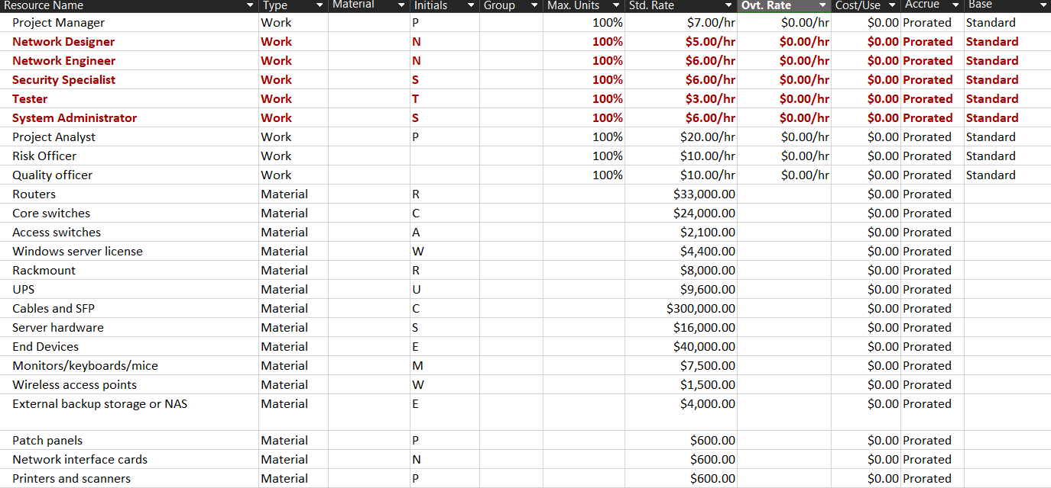

Figure 86 Appendix 3 - Resource sheet - Entry View

#### Resource Sheet – Cost View

The Figure below represent the Cost view in the Resource sheet. It shows all the material and the people will cost for the project.

Figure 87 Appendix 3 - Resource Sheet - Cost View

#### Cost-Benefit Analysis:

The below figure shows the calculation of the net present value (NVP) of the project in 6 years. This report include determent the project cost and financial outcomes to calculate the total benefit and the payback period that can be estimated from the NVP.

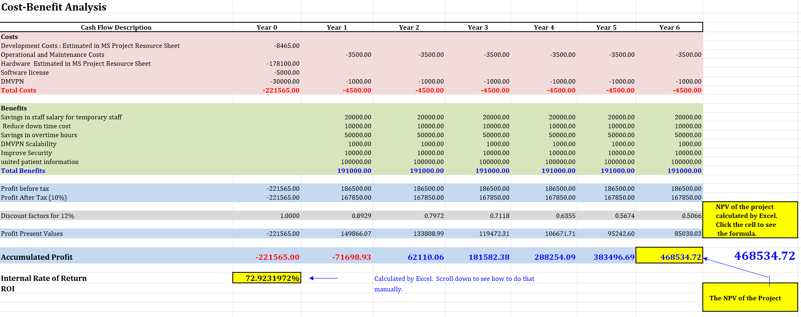

Figure 88 Appendix 3 - Cost-Benefit Analysis

#### Payback Period

The below figure shows the steps to how to calculate the payback period of the project using the NVP. The payback period is the period where all the project outcome cost starts to bay itself and the client benefit from it.

Figure 89 Appendix 3 - Payback Period

The below figure shows the payback Period in graph format for easily understanding

Figure 90 Appendix 3 - Payback Period graph

# **References**

AONMeetings. (2025, June 26). *What are the requirements for a video conferencing session.* Retrieved October 5, 2025, from AONMeetings.com website: <https://aonmeetings.com/what-are-the-requirements-for-a-video-conferencing-session/>

Arcserve. (2020, June 17). *Backup best practices: Why you should follow the 3-2-2 rule.* Retrieved from <https://www.arcserve.com/blog/backup-best-practices-why-you-should-follow-3-2-2-rule>

Cisco. (n.d.). *Role-based CLI access.* Retrieved from <https://www.cisco.com/c/en/us/td/docs/ios-xml/ios/sec_usr_cfg/configuration/xe-3s/sec-usr-cfg-xe-3s-book/sec-role-base-cli.pdf>

Cisco. (2019, January). *Dynamic multipoint VPN (DMVPN).* Retrieved from <https://www.cisco.com/c/en/us/products/collateral/security/dynamic-multipoint-vpn-dmvpn/data_sheet_c78-468520.html>

Davis, J. (n.d.). *Cisco application centric infrastructure.* Retrieved from <https://www.cisco.com/c/dam/en/us/solutions/collateral/data-center-virtualization/application-centric-infrastructure/aci-guide-naming-convention-best-practices.pdf>

Emergency network connectivity for hospitals. (2025). *Teltonika Networks.* Retrieved October 31, 2025, from <https://www.teltonika-networks.com/use-cases/enterprise/emergency-network-connectivity-for-hospitals>

GeeksforGeeks. (2017, March 7). *Types of network topology.* Retrieved from <https://www.geeksforgeeks.org/computer-networks/types-of-network-topology/>

GlobalSuite Solutions. (2023, March 20). *What is the ISO 27001 standard and what is its purpose?* Retrieved from <https://www.globalsuitesolutions.com/what-is-the-iso-27001-standard-and-what-is-its-purpose/>

Gurutech Networking Training. (n.d.). *Project 7.* Retrieved from <https://gurutechnetworks.otombenard.com/assetsProject/project7>

JumpCloud. (2025, July 22). *What is route summarization/aggregation?* Retrieved from <https://jumpcloud.com/it-index/what-is-route-summarization-aggregation>

Michal Remper, CCIE#8151. (n.d.). *Cisco medical grade network campus architectures.* Retrieved from <https://www.cisco.com/c/dam/global/sk_sk/assets/expo2011/pdfs/Cisco_Medical_Grade_Network_MichalRemper.pdf>

Molenaar, R. (2013, February 21). *Introduction to redistribution.* Retrieved from <https://networklessons.com/ip-routing/introduction-to-redistribution>

PyNet Labs. (2023, May 1). *What is route redistribution? - Networking basics 2023.* Retrieved from <https://www.pynetlabs.com/what-is-route-redistribution/>

Staff, C. (2024). *Border gateway protocol (BGP): An overview.* Retrieved October 5, 2025, from <https://www.coursera.org/articles/border-gateway-protocol>

We, H., Bin, I., & Al Khalifa. (n.d.). *Law No. (30) of 2018 with respect to personal data protection law.* Retrieved from <https://www.pdp.gov.bh/en/assets/pdf/regulations.pdf>